1. Write a Python program to check that a string contains only a certain set of characters (in this case a-z, A-Z and 0-9).

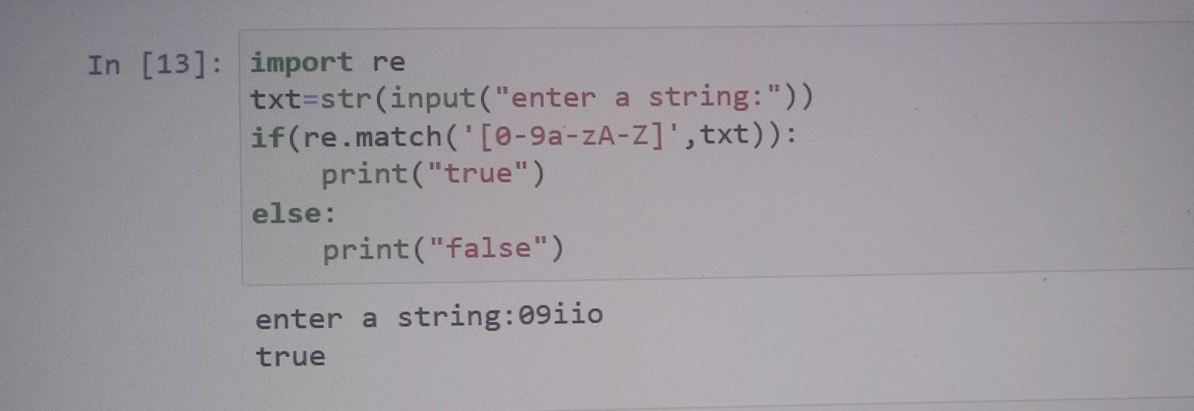

2. Write a Python program that matches a string that has an a followed by zero or more b's.

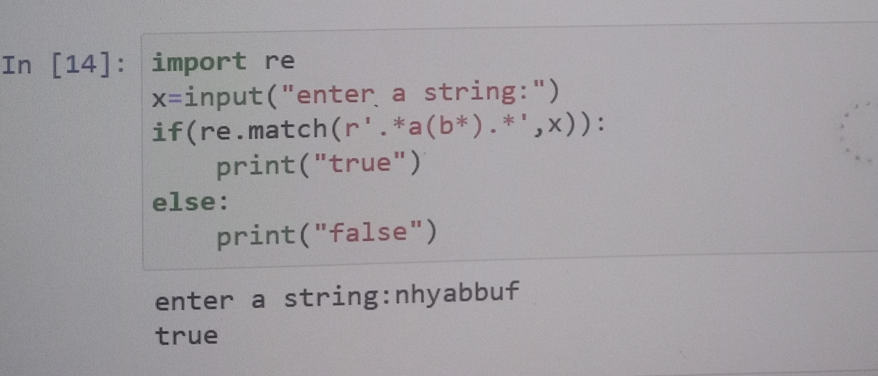

3. Replace only the first occurrence of 5 with five for the given string

ip = 'They ate 5 apples and 5 oranges'

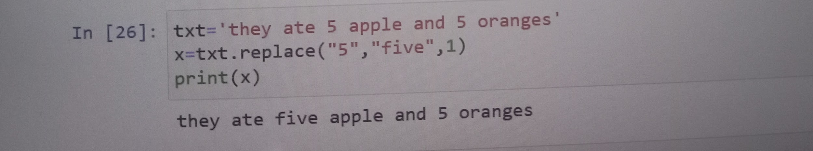

4. Write a Python program that matches a string that has an a followed by three 'b'.

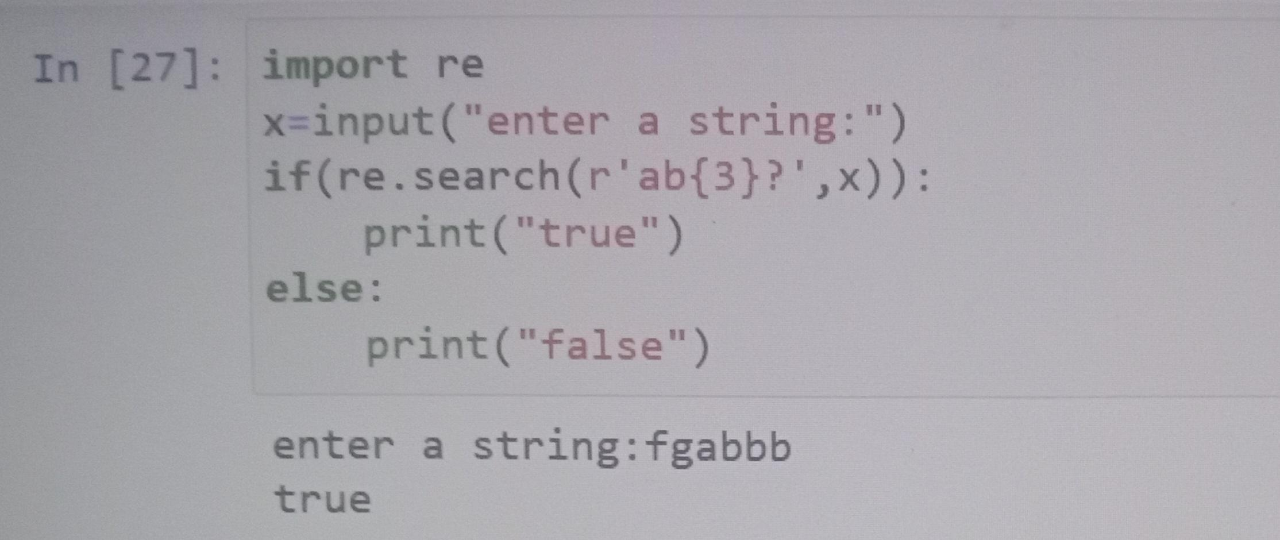

5. Write a Python program that matches a string that has an 'a' followed by anything ending in 'b'.

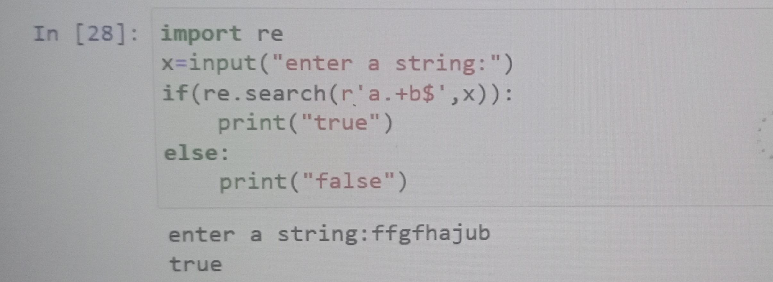

6. Write a Python program to search for numbers (0-9) of length between 1 and 3 in a given string.

txt="Exercises number 1, 12, 13, and 345 are important"

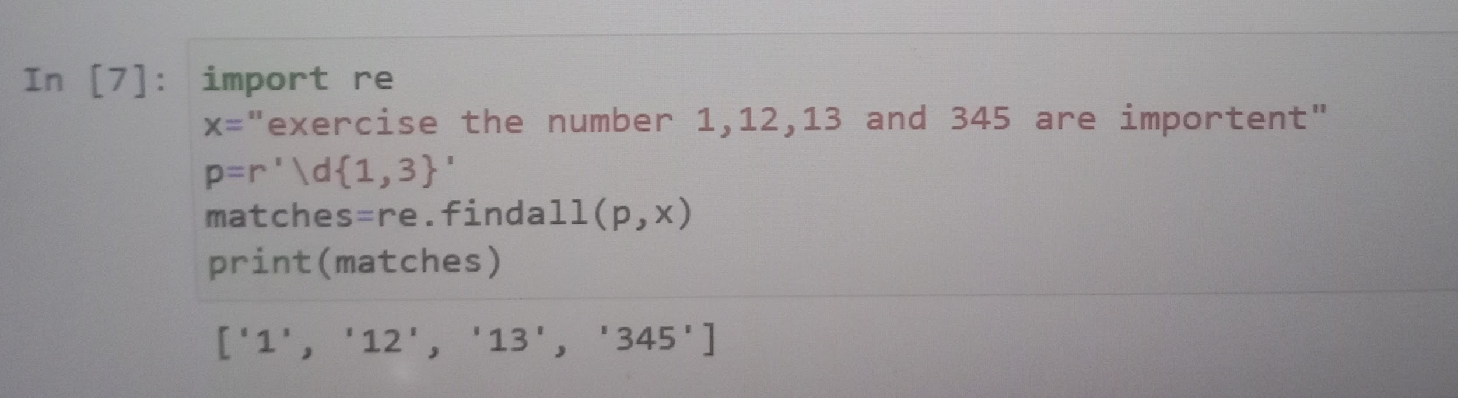

7. Write a Python program to search for literal strings within a string.\

Sample text : 'The quick brown fox jumps over the lazy dog.' \

Searched words : 'fox', 'dog', 'horse'

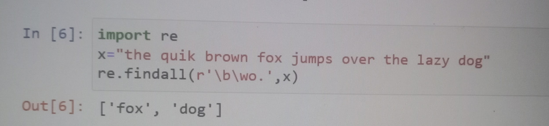

8. Write a Python program to search for a literal string in a string and also find the location within the original string where the pattern occurs.

Sample text : 'The quick brown fox jumps over the lazy dog.'

Searched words : 'fox'

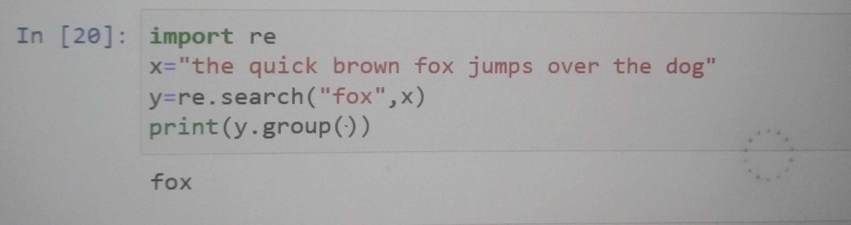

9. Write a Python program to extract year, month and date from an URL

url1= "<https://www.washingtonpost.com/news/football-insider/wp/2016/09/02/odell-beckhams-fame-rests-on-one-stupid-little-ball-josh-norman-tells-author/>"

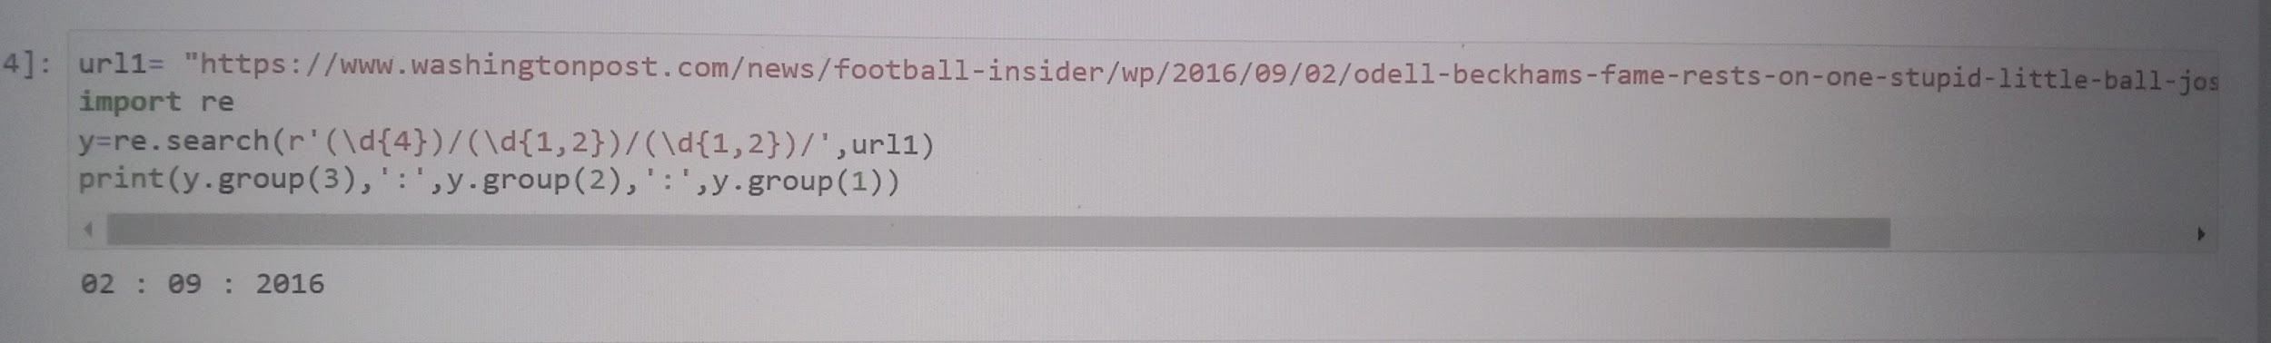

10. Write a Python program to find URLs in a string.

text = '<p>Contents :</p><a href="https://w3resource.com">Python Examples</a><a href="http://github.com">Even More Examples</a>'

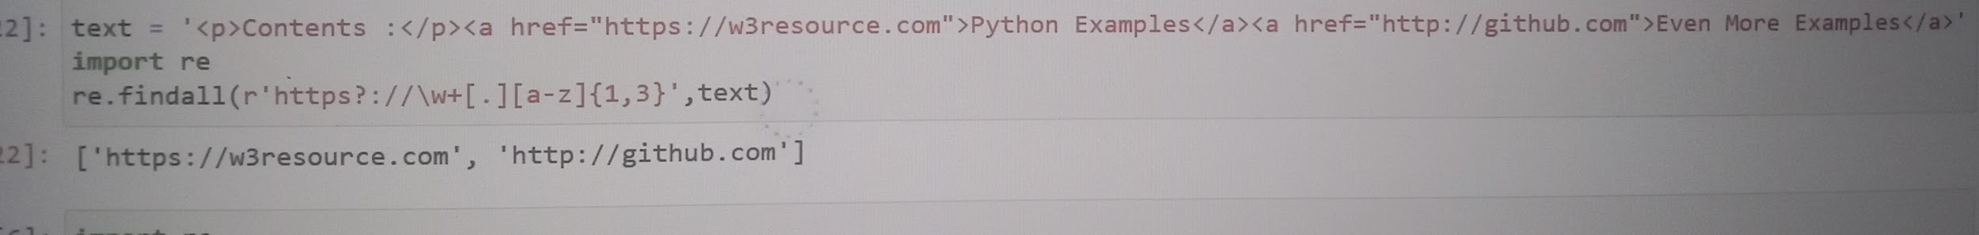

11. Write a Python program to remove the parenthesis area in a string.

Sample data : ["example (.com)", "w3resource", "github (.com)", "stackoverflow (.com)"]

Expected Output:

example

w3resource

github

stackoverflow.

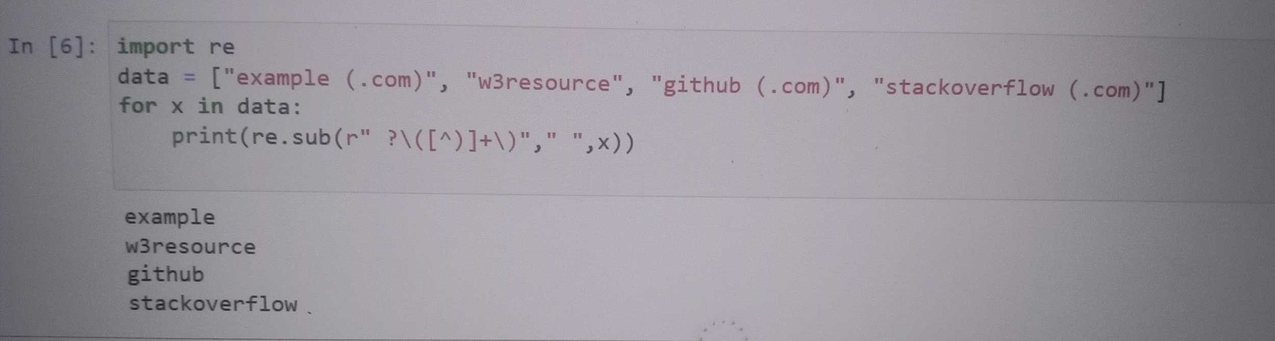

12. Write a Python program to concatenate the consecutive numbers in a given string. \

Original string:

Enter at 1 20 Kearny Street. The security desk can direct you to floor 1 6. Please have your identification ready.

After concatenating the consecutive numbers in the said string:

Enter at 120 Kearny Street. The security desk can direct you to floor 16. Please have your identification ready.

